Adaptive Radiation Causes Differences in the Morphology of Lizards in Arboreal Habitats

Sherwin Miller

Evolution

Dr. Mitchell

May 1st, 2020

**Abstract**

Adaptive radiation has been a long-explored topic in evolutionary biology amongst related species. This paper aim to explore if these radiating traits are present amongst *Anolis* and *Cryptoblepharus* lizards. In an effort to look at how these species have differentiated based on their environment, different body part lengths were analyzed. The lengths analyzed were fore-limb length, snout-vent length, rear-limb length, head width, and ear to limb length. After conducting an MANOVA test on each length across the five species included, it was concluded that there is a significant difference between the body part lengths of each species.

**Introduction**

Adaptive radiation is one of the central topics in evolutionary biology. Adaptive radiation is termed as an array of species that live in different environments with corresponding traits and results from the differentiation of a single common ancestor (Schulter D. 2000). There can be environmental factors affecting the habitat the lizard lives in. These environmental factors include temperature, predation, and resources. Temperature affects the life history of the lizard and its traits (Meiri et al. 2013). Temperature can also affect body size as well (Velasco et al. 2020).

There are different habitats that lizards live in such as arboreal, saxicolous, and littoral. Each of these habitats are similar and different. Arboreal habitats consist of organisms that live in trees. The structure of arboreal habitats affects the organism’s locomotion. The organism’s locomotion in an arboreal habitat depends on the incline, length, and diameter of the perch (Mattingly and Bruce 2004). Saxicolous habitats consist of organisms that is living in rocks. Littoral habitats consist of organisms living near the shore area of lakes. These habitats offer resources that are available for many vertebrates and invertebrates. However, these habitats are affected negatively by human activities which causes an increase in nutritional loading, spreading invasive species, acidification, climate change, and increased fluctuation in water level (Peters and Lodge 2009).

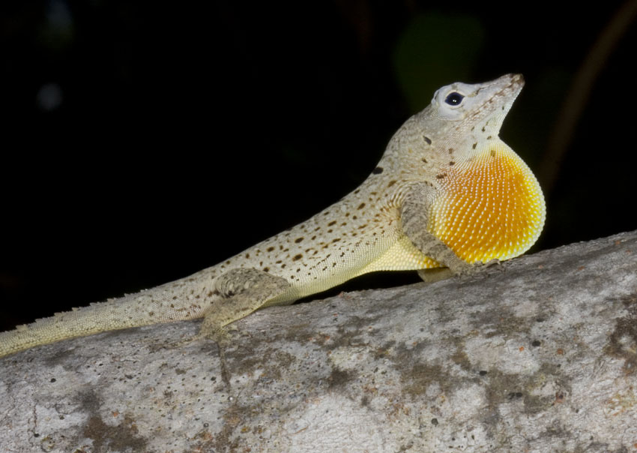

**Figure 1**. *A photograph of Anolis stratulus* (Cope 1861).

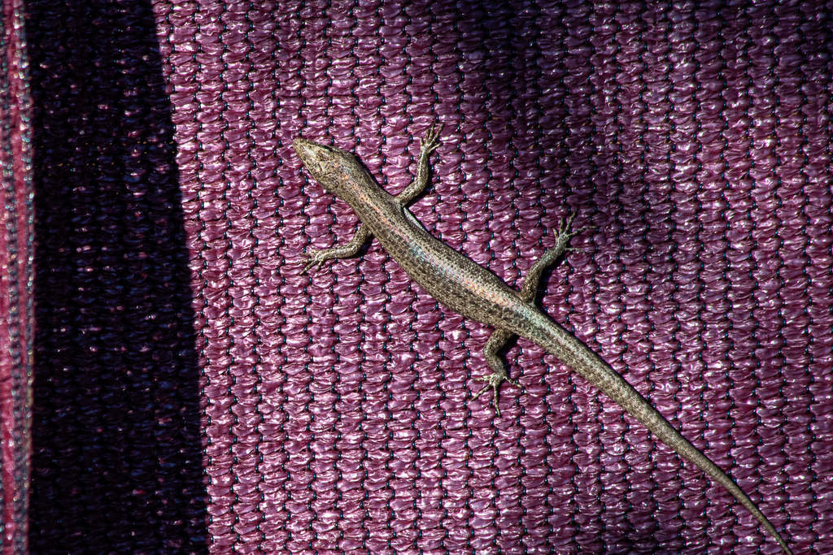

**Figure 2**. *A photograph of Cryptoblepharus ruber (Borner and Schuttler 1981).*

*Anolis* and *Cryptoblepharus* lizards are both great for studying adaptive radiation. As shown on Figure 1, *Anolis* lizards are typically green, brown, or grey. They approximately weight 1- 10 grams and have a body length of 35-85 mm. The two traits that distinguish *Anolis* from other genera are expanded toepads and a dewlap which is an extensible colorful flap of skin that is attached to the throat (Losos and Schneider 2009). As shown on Figure 2, *Cryptoblepharus* lizards are defined by having a snake-eye appearance. These lizards are variable in color and have spectacles on their eyes instead of a moving eyelid (Vitt 2018).

This paper will look into the differences of body parts in the same type of habitat in lizards. The type of habitat that will be examined is an arboreal habitat. My hypothesis is that the body parts of lizards living in the same type of habitat are significantly different due to their environment.

**Materials and Methods**

To test this hypothesis, data was obtained from Blom et al. (2016) in Dryad and from Kolbe et al. (2016) in Figshare. Dryad is an international repository that contains research data and data from scientific and medical publications. Figshare is a repository where researchers can submit their datasets, figures, images, and videos. Dryad and Figshare are great places to get evolutionary data. The data from Blom et al. (2016) contains the species of the genus *Cryptoblepharus* along with their habitats and the length and width of their body parts. These habitats include saxicolous, littoral, and arboreal. Body parts include SVL (snout-vent length), FL (forelimb length), RL (rear-limb length), HL (Hind-limb length), SE (snout length), CHEEK (eye to ear length), NECK (ear to limb length), head height (HH), and head width (HW). The species that were used in this hypothesis for the *Cryptoblepharus* are *ruber, metallicus*, and *buchananii*. In this dataset, these species live in Australia. Data from Kolbe et al. (2016) contains two species of the *Anolis* genus along with their sex. The Anolis lizards from this dataset were living in human modified arboreal habitats. The body parts of the Anolis lizards were measured in millimeters and their mass was measured in grams. Their body parts include SVL (snout-vent length), femur length, tibia length, 4th toe metatarsal length, 4th toe phalanges length, humerus length, ulna length, 3rd-toe metatarsal with phalanges length, head length, pectoral width, pelvis width, tail length, 3rd toe forefoot toepad, and 4th toe hindfoot toepad. For this hypothesis, snout-vent length, ear to limb length, rear-limb length, head width, and fore-limb length were used.

In order to test the significant differences of body parts between lizards living in the same habitat, an MANOVA test was used in R. R is a programming language that is used by statisticians for data analyses (R Core Team 2019). Generally, MANOVA tests are only used when there are several dependent variables. For snout-vent length and head width, C. *ruber, C. metallicus, C. buchananii, A. cristatellus*, and *A. stratulus* species were used. For fore-limb, rear-limb, and ear to limb length, C. *ruber, C. metallicus*, and C. *buchananii* were used. In order to make the MANOVA test work, manova() and cbind () functions were used to combine the data and were saved under the object bodyparts.manova. The summary () function was used to look at the significance of body parts for species overall. In addition, the summary.aov () function was used to look at the significance of each body part. Box plots were made for Figures 3-7 by using the plot () function. Lastly, a phylogeny tree was generated from phylo T using NCIB taxonomy data for *Crytoblepharus ruber*, *Cryptoblepharus metallicus*, *Anolis stratulus*, and *Anolis cristatellus (*Figure 8). Unfortunately, there was no taxonomy data for *Crytoblepharus buchananii* from NCIB to be generated into the phylogeny tree.

**Results**

The MANOVA test for snout-vent length was calculated as a degree of freedom of 2, sum square of 384.86, mean square of 192.43, F value of 13.657, and a p value of 5.957 x 10-6. The MANOVA test for fore-limb length was calculated as degree of freedom of 2, sum square of 5.093, mean square of 2.55, F value of 1.54, and a p value of 0.22. The MANOVA test for rear-limb length was calculated as a degree of freedom of 2, sum square of 8.86, mean square of 4.43, F value of 1.69, and a p value of 0.19. The MANOVA test for ear to limb length was calculated as a degree of freedom of 2, sum square of 8.46, mean square of 4.23, F value of 4.93, and a p value of 0.0091. The MANOVA test for head width was calculated as a degree of freedom of 2, sum square of 5, mean square of 2.49, F value of 11.67, and a p value of 2.88 x 10-5. The MANOVA test for the overall body sizes of species was calculated as a degree of freedom of 2, F value of 7.43, and a p value of 6.49 x 10-10 The species with the highest snout-vent length was *A. cristatellus* and the species with the lowest snout-vent length was C. *buchananii* (Figure 3). The species with the highest head width was *A. cristatellus* and the species with the lowest head width was C. *buchananii* (Figure 4). For forelimb length, C. *buchananii* was the highest and C. *ruber* was the lowest (Figure 5). For rear-limb length, the highest was C. *buchananii* and C. *ruber* was the lowest (Figure 6). Lastly, for ear to limb length, the highest was C. *metallicus* and the lowest was C. *ruber* (Figure 7). Based on the phylogeny from Figure 8, the *Cryptoblepharus* species and the Anolis species share a common ancestor. Also, from Figure 8, *Cryptoblepharus ruber* and *Cryptoblepharus metallicus* share a most recent common ancestor and are closely related whereas *Anolis stratulus* and *Anolis cristatellus* share a most recent common ancestor and are closely related.

**Figure 3.** *A box plot of* *Species vs. Snout-Vent Length***.**

**Figure 4.** *A box plot of**Species vs. Head Width.*

**Figure 5.** *A box plot of* *Species vs. Fore-limb length.*

**Figure 6.** *A box plot of**Species vs. Rear-limb length.*

**Figure 7.** *A box plot of**Species vs. ear to limb length.*

**Figure 8**. *A phylogeny of Anolis and Cryptoblepharus.*

**Discussion**

Based on the results, fore-limb length, head width, rear-limb length, ear to limb length, and snout-vent length are all significantly different between species. This was determined by the p value being less than the significance value from the MANOVA test. From Figure 3 and Figure 4, *A.cristatellus* had the highest snout-vent length and head width. From Figure 5 and 6, *C. buchananii* had the highest fore-limb and rear-limb length. From Figure 7*, C. metallicus* had the highest ear to limb length.

Although each of these species live in the same habitat with the same climate, resources, and predation, it is reasonable that there are differences in body parts as some lizards are longer and wider than others. It could also be that some of the lizards were younger. Another reason is it could be due to the body mass of the lizards. However, the datasets did not contain the ages of the lizards and only one dataset contained body mass from *Anolis* and not the *Crytoblepharus*. The differences could be due to the *Cryptoblepharus* species sharing a more recent common ancestor and are closely related than the *Anolis* species (Figure 8). Also, the differences could be due to the human modified habitat of the *Anolis* lizards. Kolbe et al. (2016) found that changes in the diameters of perches for anoles show rapid adaptive change to their traits. They found in a natural arboreal habitat that *A.cristatellus* occupied trunks, rocks, ground, and branches whereas *A.stratulus* occupied only branches and trunks. Also, they found that based on the morphology, certain *Anolis* lizards will adapt to a certain substrate. They found that in a human modified arboreal habitat that *A. cristatellus* occupied posts and walls whereas *A. stratulus* occupied posts, walls, and trunks. This could explain why *A. cristatellus* has a higher snout-vent length and head width than *A. stratulus* due to adapting to a new environment. Blom et al. (2016) found that differences between body parts of the *Cryptoblepharus* arboreal species was due to their sprint performance of the changing diameters of arboreal surfaces in their environment. This could be a reason why *C. metallicus* has a higher ear to limb length and *C. buchananii* has higher fore-limb and rear-limb lengths. If there was data of the diameter of perches for the species of *Crytptoblepharus*, it would better support the hypothesis. Temperature could have played a role in the differences of the body parts. However, there was no temperature recorded in the datasets. There could also be some errors in my hypothesis such as an uneven number of samples for each species. If each of the species had the same number of samples, this would account for less possible errors in the MANOVA test. In the future, I hope to look further into how adaptive radiation can cause these differences in the body parts of these lizards by looking into temperature and the different types of habitats.

**Works Cited**

Blom, Mozes P K et al. “Convergence across a continent: adaptive diversification in a recent radiation of Australian lizards.” *Proceedings. Biological sciences* vol. 283,1832 (2016): 20160181.

Borner and Schuttler. *Cryptoblepharus ruber.* 1981. *The Reptile Database*. <http://reptile-database.reptarium.cz/species?genus=Cryptoblepharus&species=ruber&search_param=%28%28search%3D%27Cryptoblepharus%27%29%29>.

Cope. *Anolis stratulus*. 1861.*The Reptile Database. http://reptile-database.reptarium.cz/species?genus=Anolis&species=stratulus*

Kolbe, Jason J, et al. “City Slickers: Poor Performance Does Not Deter Anolis Lizards from Using Artificial Substrates in Human‐Modified Habitats.” *Functional Ecology*, vol. 30, no. 8, 2016, pp. 1418–1429.

Losos JB, and Schneider CJ. “Anolis Lizards.” *Current Biology: Cb*, vol. 19, no. 8, 2009, pp. 316–8.

Mattingly, W. Brett, and Bruce C Jayne. “Resource Use in Arboreal Habitats: Structure Affects Locomotion of Four Ecomorphs of Anolis Lizards.” *Ecology*, vol. 85, no. 4, 2004, pp. 1111–1124.

Meiri, Shai, et al. “Are Lizards Feeling the Heat? A Tale of Ecology and Evolution Under Two Temperatures.” *Global Ecology and Biogeography*, vol. 22, no. 7, 2013, pp. 834–845.

Peters, J.A, and D.M Lodge. “Encyclopedia of Inland Waters.” *Littoral Zone*, 2009, pp. 79–87.

Schluter D. 2000. The ecology of adaptive radiation. Oxford, UK: Oxford University Press.

R Core Team (2019). R: A language and environment for statistical computing. R Foundation for Statistical Computing, Vienna, Austria. https://www.R-project.org/.

Velasco Julián A, et al. “Macroecology and Macroevolution of Body Size in Anolis Lizards.” *Ecography*, (20200213), 2020.

Vitt, Laurie. “Skink.” Encyclopædia Britannica, 10, Oct. 2018, <https://www.britannica.com/animal/skink>.